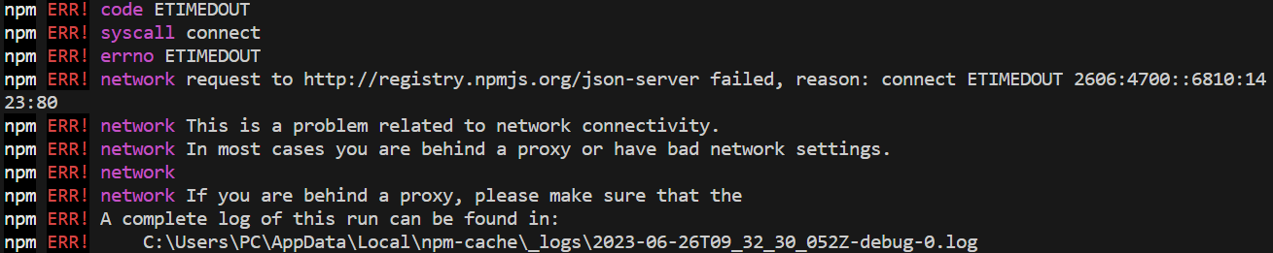

**Khắc phục:**

npm config delete proxy

npm config delete http-proxy

npm config delete https-proxy